1. In the folder to create a repository/project, do “git init” to initialize.
2. 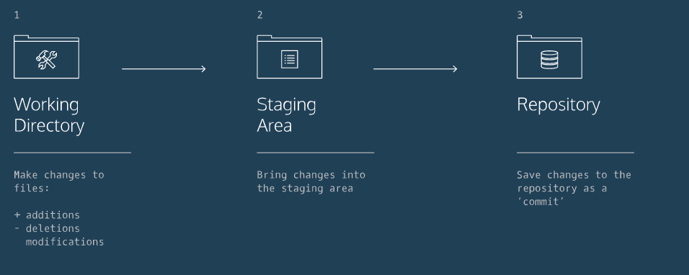
3. “git status” to check status of files in the working directory
4. “git add (filename)” to add to the staging area
5. “git commit -m (add message here, must be in quotes)” to commit to the repository
6. “git checkout HEAD filename” will restore file to what it was at commit status, keeps in staging area
7. “git reset HEAD (filename” unstages file from staging area, resets file
8. “git reset (first 7 letters of SHA commits)” to reset back to a certain commit
9. “git branch” checks which branch you are currently on
10. “git branch (branchname)” to create a new branch
11. “git checkout (branchname)” to switch to a branch
12. “get merge (branchname) to merge branch into current branch, update
13. “git branch -d (branchname)” to delete branch after successful merge
14. “git clone (remote location) (name for cloned directory):
15. “git remote -v” lists remotes for that directory
16. “git fetch” will update the directory, it will not merge, just bring into a remote branch for further use
17. “git merge origin/master”
18. “git push origin (branchname)” Pushes my new directory to the original directory for update